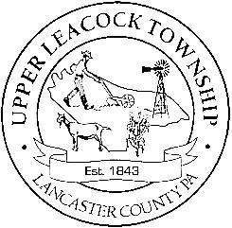
Upper Leacock Township
Board of Supervisors

161 Newport Road, Leola, PA 17540
(717) 656-9755 • FAX: (717) 656-9609
www.ultwp.com
RONALD S. SIMMONS
CHAIRMAN

J. HAROLD LEAMAN
VICE-CHAIRMAN

JAMES J. BENNETT
SUPERVISOR

MICHAEL H MORRIS
TOWNSHIP MANAGER

Dear Water & Sewer Customer:

Upper Leacock Township has been offering direct debit (ACH) as a means of paying your quarterly water and sewer bills. It’s easy! Just call our office if you are interested, and we will take the following steps to get you set up for this type of payment:
- We have forms in our office for you to fill out showing your bank name, account number, routing number, etc. This form can be picked up or mailed to you.

- You will need to include a voided check for verification of your bank information.

- It will take approximately two weeks for this information to be set up with Fulton Bank and to be verified.
Once your account is set up for direct debit, our office will withdraw the amount of your bill from either your checking or savings account approximately on the 12th of the month that you are billed. If the 12th falls on a weekend or holiday we will debit your account as close to the 12th as possible. You will still get your regular water/sewer bill in the mail which will be marked “Do Not Pay”.
It’s that easy! Call the Township office at 717-656-9755 for more details or to have the paperwork sent to you.

Sincerely,
Upper Leacock Township

